Using Bears Race to 10 for Math Fact Fluency:
- Purpose: Foundational Fact Strategy Game for Addition
- Foundational facts must precede derived facts. The foundational facts are critical building blocks for the types of fact strategies fluent students create.
- The first group of facts to master involve adding or subtracting 0, 1, or 2. This is because these facts relate closely to the counting sequence.
- Visual tools such as number lines are especially helpful for connecting these facts to the counting sequence.
- As students play Bears Race to Ten, ask students to say or write equations to match so that they make the connection between the movement of the bears (concrete) and the equation (abstract).
About Games and Math Fact Fluency:
Games are fun. But, more importantly, games are effective ways to support learning. Games provide opportunities for:
- low-stress practice of (1) facts and (2) strategies (both outcomes are critical to math beyond the basic facts!).
- think aloud, an effective learning strategy. Therefore, students should develop the habit of verbalizing their mathematical thinking out loud.
- student listening and learning from peers. Therefore, discussing strategies before and after playing allows students opportunities to learn from each other.
- teachers to formatively assess and plan instruction. Therefore, at times, use an observation tool to record how students are progressing.
Effective math fact fluency games remove time pressure and allow students time to think. That means no time component. Each player has their own cards or dice to roll, so they are not racing each other. Scoring is de-emphasized. Thinking strategies are front and center.
Bears Race to Ten 2 players
Materials: For each pair of players, you need: two number lines from 0-10 (or a game board with squares labeled 0-10) to be a “racetrack” (one for each student), two plastic bears or counters (one for each student), a die labeled +0, +0, +1, +1, +2, +2 . See variations for Racing Bears on page 25. A scoring option is included for those students ready to write equations.
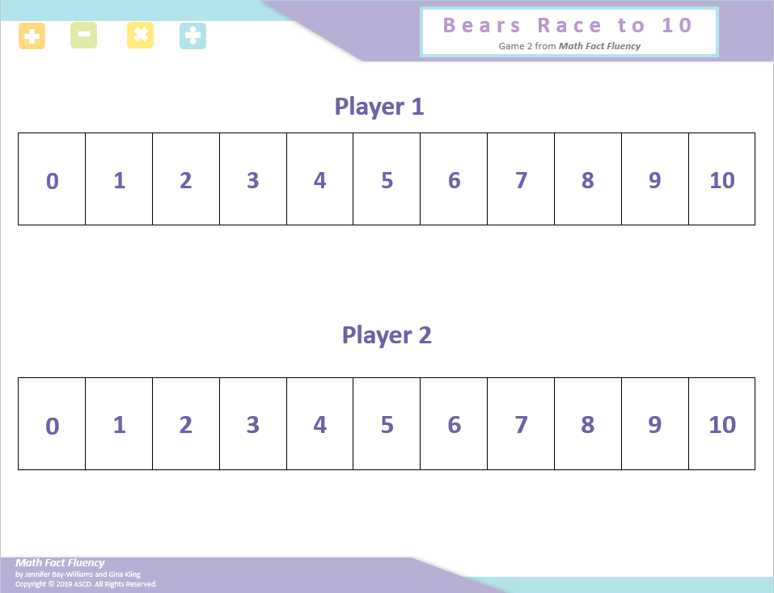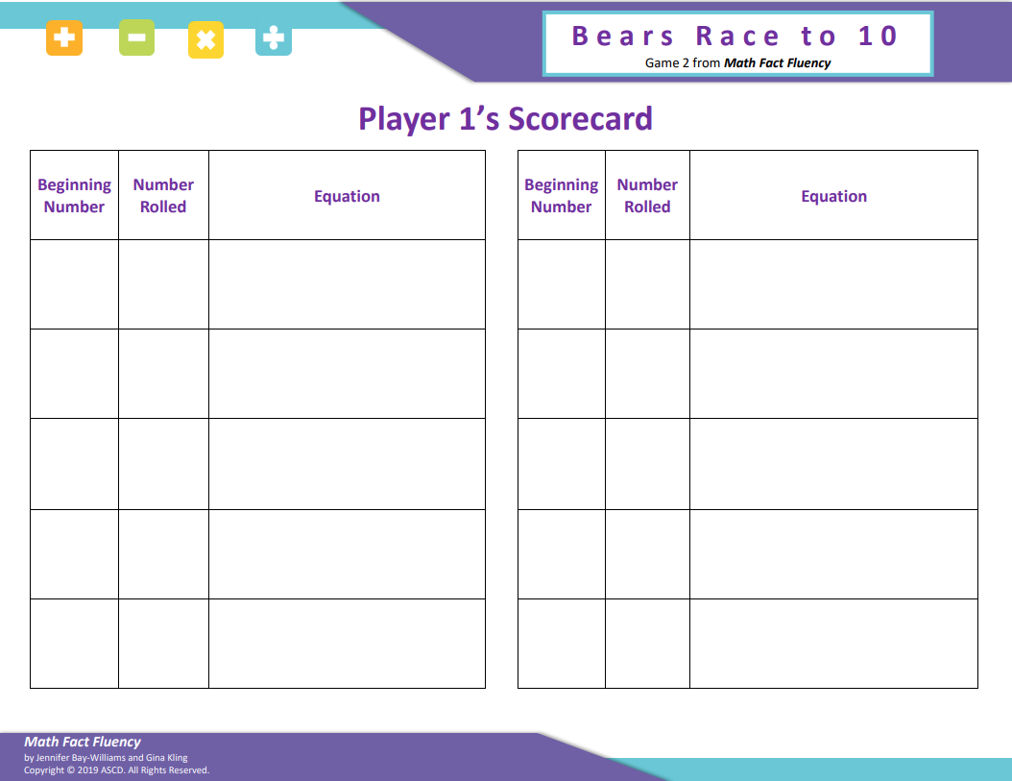
Game Board Score Card

Bears Race to Ten 2 Players
How to Play:
- Students start their bears at 0.
- Using the die labeled as +0, +0, +1, +1, +2, +2, Player 1 rolls the die and moves his/her bear the appropriate number of spaces.
- Player 1 says the addition sentence that matches the movement of the bears. (e.g., A student is on the 6th square and rolls +2. The student would say “6 plus 2 equals 8.”)
- If developmentally appropriate, the student may record the number sentence on the scorecard.
- Repeat all steps for Player 2.
- The first bear to 10 wins the race.
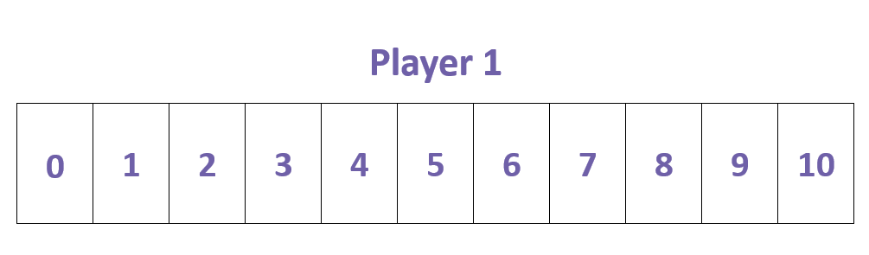
Game in Action:

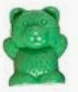
+2
I am on 4 and I rolled a +2. That means I get to jump ahead two spaces to 6! 4 plus 2 equals 6.

Possible Variations:
- Use a vertical number line. Students start at 0 and move up the number line.
- Use 0 – 20 number line to increase difficulty when students are fluent to 10.
- Gameboard can also be used for Game 3: Bears Race to 0 and Game 4: Bears Race to Escape

